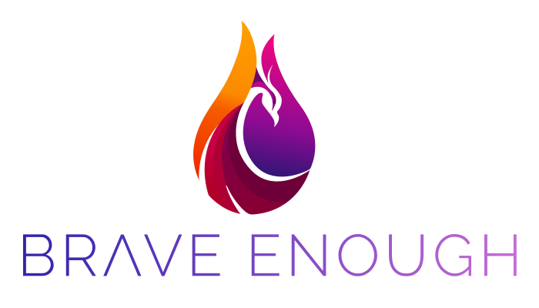
Brave Enough 2022 Women’s Conference
September 29 -October 2, 2022 Scottsdale, Arizona
Omni Scottsdale Resort & Spa

Lance A. Shillcutt, MPT CSCS
Chief Operating Officer
lance@becomebraveenough.com
402-658-6048

Thank you for applying for the Brave Enough Women’s CME Conference scholarship! Please email this completed form to Dr. Leigh Johnson at leighj00@gmail.com by July 15, 2022 at 11:59PM CST.

SCHOLARSHIP APPLICATION FORM

Full Name:

Email Address:

Phone Number:

Job Location (Address, City, State, Zip Code):

Profession:

Degree/ Credential/ Professional Title (i.e., MD, DO, PhD, RN, MS, BS, etc.):

Years in Practice:

Have you ever attended a previous BE Conference?

Please explain below why you are applying to this scholarship and how it will help you:

What is it that you hope to achieve through this scholarship?

